[logo](https://staging.edgrow.in/) **Header Section**

**Verify High Level Designed**

* Testing the application randomly without any test cases or business requirement documents and functional requirement documents I conduct Adhoc testing of application with my analytical skills I understand to the test scenarios I prepared a documents based on that documents I will explored each & every features of application and each & every scenario there will be multiple scenarios will be there for each scenario I will derived multiple test cases.

Now here I’m doing my observation about Edgrow

Observation about Edgrow ,Validate the Homepage of Edgrow I observed some functions aren’t working properly I can’t able to understand which is bug or enhancement whichever the yellow and Red line you see that all are I mentioned and I consider that is bug please check whether my observation is correct or not.

**1 ) The heading name of the website is aligned to the left side of the "Homepage."**

The colors and font on the “ Edgrow” website is cool and if we look left side of UI there is LOGO we may see on top of Logo there is one curly arrow and we clear seen on the circles at arrow and the arrow is small size it not covered the logo arrow looks small we can remove it for better look the name of website or also we can increase the size of arrow.

The font on the Edgrow website is stylish and aesthetically pleasing, but it appears to be

on the smaller side. To enhance the overall visual appeal of our website and make a

strong first impression on our users, we should consider increasing the font size for the

heading "Edgrow." Fortunately, we have space available for making it a straightforward

adjustment.

**2) On the right side of the "Homepage" header section, there are some options available.**

[Home](https://staging.edgrow.in/) [Blogs](https://staging.edgrow.in/blogs) [Courses](https://staging.edgrow.in/courses) [Contact](https://staging.edgrow.in/contact) Login

* **HOME**: while I clicked it will be proper navigate to Homepage on different section
* **BLOGS** : under the blogs there some different options

All Blogs Categories

Coding

Test

Testing

Technical Test

When we clicked the blogs option it will be proper navigate to same of Homepage at different section and under the blogs there are some options will be there which as All the blogs,coding,test,testing,technical test while we click these option these all are properly worked we no need to do anything on that.

* **Courses:** when we select courses, it has properly showing 11 courses details like it shows

Courses fee amount and discount

Videos duration 0-2 Hours, 3- 6 Hours 7-14 Hours 16+ Hour

Courses rating with ****

languages HINDI ENGLISH and Both Hindi and English

All these options are working fine according we won’t change anything.

* **Contact :** when I click this option, we can see contact detail like Our Location, Email ID, Contact Numbers.
* **Login :** When I click login option it will navigate to login page properly
* **Whish List:** while we click it there is shown go to cart, I see there is spelling mistake Got to cart so here observe a bug we have to implement and fix the bug.

Right Side of Header section there is Get A Demo Button is placed, size of button, color, is looks good.

**Get A Demo:** when click this button it has proper ask to users Full Name, Mobile Number, Profession, city and privacy checkbox and captcha is mandatory to select get demo button is working fine we no need to change anything.

**Middle of the “Homepage”**

There on Certificate Image the designers have do some mistakes on Certificate image we can clearly see some lines are going outers of the image it looks very bad the designers have to implement on certificate image and remove the lines

|  |
| --- |
| **Companies Where Our Students Are Working**  **Our Curriculum is practically tailored to upskill yourself so that you land a decent job in top tier companies across the world. We believe that If you learn with the innovation and learning mindset, getting a job is not a big deal. So at edgrow we have everything to train you and boost your confidence to become future innovators.**  [**Learn More**](https://staging.edgrow.in/welcome/about) when I click this button it haven’t navigate to anywhere there no target page it shows **404 - File Not Found so here I found bug** |

**I noticed that on the right side, over 3000 students have been placed** the name of company with their Images are seems good as per my view we won’t change anything.

**3,000+Students Placed**

[brand imagebrand imagebrand imagebrand image](https://staging.edgrow.in/)

[brand imagebrand imagebrand imagebrand imagebrand image](https://staging.edgrow.in/)

##### **Testimonials**

## Student's Feedback

I came across a total of 12 student feedback entries, and I noticed that all of them were satisfactory.

Student photo student name of student rating and feedback spelling that all are correct there no bug observed that all are fine.

**From the Aduca community**

**Donec vitae orci sed dolor rutrum auctor. Duis arcu tortor, suscipit eget, imperdiet nec**

**I can’t understand what the developers has written this so that’s why I confirmed that is bugs**

[**Explore all**](https://staging.edgrow.in/about.html) 🡨 when I click this button it hasn’t navigate anywhere there no target page it shows **404 - File Not Found Here observed that is bug**

**Sign up for our newsletter** Stay in the know on new free e-book Subscribe when I click this subscribe button it hasn’t going anywhere it does not show anything so that is one more bug observed.

Top of Form

Bottom of Form

**Footer Section of “Homepage”**

Name of Website and font is looking good no need to change that

* Left side of footer so here I see the name of Website and email id link is placed [info@edgrow.in](mailto:info@edgrow.in)

while clicked this link it redirects to email page directly.

### We are on

Website is available on social sites which mentioned as their logos

Facebook Instagram LinkedIn Twitter YouTube

While I clicked this these logos these are all working fine and it navigate to different page and we saw our website detail will be there.

At footer section there is some multiple options will be there

### Company

* [About us](https://staging.edgrow.in/about) 🡨 when I click this it will navigate to about us same page of website
* [Contact us](https://staging.edgrow.in/contact) 🡨when I click this option Location Email ID Contact Numbers is available
* [Terms And Conditions](https://staging.edgrow.in/terms-and-conditions) 🡨 when I click this [Terms And Conditions](https://staging.edgrow.in/terms-and-conditions) will be displayed
* [Privacy Policy](https://staging.edgrow.in/privacy-policy) 🡨when I click this option [Privacy Policy](https://staging.edgrow.in/privacy-policy) will be displayed
* [Find Jobs/ Internships](https://staging.edgrow.in/joblist) 🡨 [Find Jobs/ Internships](https://staging.edgrow.in/joblist) properly displayed
* [Blogs](https://staging.edgrow.in/blogs) 🡨 blogs with images are displayed properly

### Courses

* [Python](https://staging.edgrow.in/) 🡨 when click this python course it hasn’t navigate anywhere here no target page
* [Data Science](https://staging.edgrow.in/) 🡨 when click this Data Science course it hasn’t navigate anywhere
* [Machine Learning](https://staging.edgrow.in/) 🡨 when click this python course it hasn’t navigate anywhere
* [Artificial Intelligence](https://staging.edgrow.in/)🡨 when click this python course it hasn’t navigate anywhere
* [Data Analytics](https://staging.edgrow.in/) 🡨 when click this python course it hasn’t navigate anywhere here no target page

On the header section there will be courses list and when we select the courses on header section that will show me the completely detail about the course which include fee duration and everything.

But if we look into footer section there is also courses option will be there while I select the courses from footer section so here website should not show me the courses detail when I click the course it hasn’t navigate anywhere so it confirmed that is bug.

### Download App

Download our mobile app and learn on the go.

[App storeGoogle play store](https://staging.edgrow.in/)

© 2022 Edgrow. All Rights Reserved. by [Edgrow](https://staging.edgrow.in/) [Terms and Conditions](https://staging.edgrow.in/terms-and-conditions) [Privacy Policy](https://staging.edgrow.in/privacy-policy)

While I click the download option it won’t go anywhere, I would not be able to download the application so that is one more bug observe at footer section

**Ragistration Page**

When I trying to registered the new account manually, I fill the mandatory field the account will be created successfully but there no confirmation massage on email id website is not sending the account successfully created link to registered email id but website showing these kinds of massage on UI

### Verify Your Email!

#### **Hi.. Shaikh, Verification Email Sent Just One Step More, Before Login..**

We Have Just ReSent You an Email Regarding Verification!

Kindly Follows The Instruction Given In The Email Sent to  
**iamshaikhzaker@gmail.com**  
For Activation of Your Account.

Regards

Edgrow.in

When I click to resend the link on ragister email the website is not sending the link on my email id that’s why I couldn’t successfully open the login page I do this thing again and again but the same result I got everytime.

So this is a bug which observed during to verifyng the ragister a new account.

While I am trying to log In with gmail option and press continue with my gmail account the account will successfully open and redirect to login page sucessfully but again I couldn’t get any confirmation email link on my ragistered email id but new account will be created and im able see the login successfully look at image which attached.

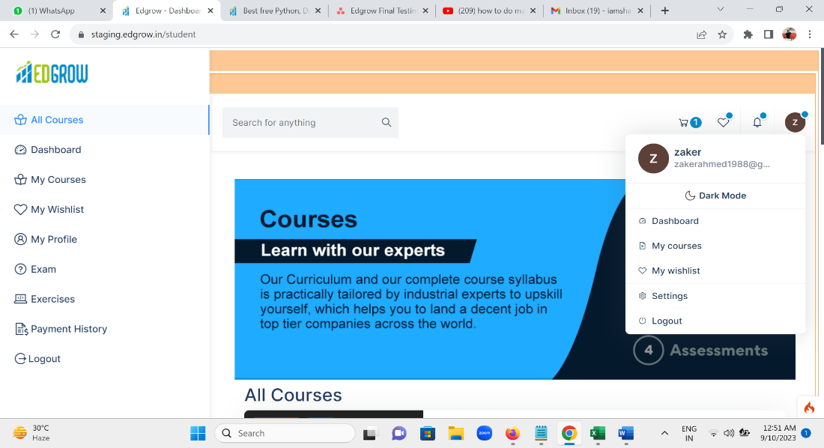

**Login succesfully page**

**Low Level Design**

Leftside of Header section there have been some options will be there I clicked that step by step and checking the flow between the module which working fine or not

[logo](https://staging.edgrow.in/)

* [All Courses](https://staging.edgrow.in/student/courses) 🡨 while clicked this it will be successfully showing the 11 courses list.
* [Dashboard](https://staging.edgrow.in/student/dashboard) 🡨 Observed here 2 bugs



Observed here 2 bug while I verify the dashboard 1-select image showing the name user and 2 –there is spelling mistakes will be there I found (Hello Howdy)

Developer has do here spelling mistakes it has to be Hello Za*** ***** but here developers wrote howdy so that’s why developer need to fix the bug.

* [My Courses](https://staging.edgrow.in/student/my-courses) 🡨 it will be perfectly worked we no need to change here its fine
* [My Wishlist](https://staging.edgrow.in/student/wishlist) 🡨 it will be perfectly worked we no need to change here its fine
* [My Profile](https://staging.edgrow.in/student/my-profile) 🡨 when I check my profile so here observed Mobile Number text Field here it shows the register mobiles number by users. 2 at Aadhar card No. Aadhar card field required 12 (Twelve) numbers only but here I caught Aadhar number field accept more than 12 numbers and it accept “Spaces ” and alphabets so Developers must promptly address these bugs as I have categorized them as high severity and priority issues. Other Edit profile mandatory field which is UPLOAD PHOTO , FIRST NAME , LAST NAME DROPDOWN , YOUR RAGISTER MOBILE NO , YOUR RAGISTER EMAIL ID AADHAR CARD NUMBER AND AADHAR FROND SIDE IMAGE AADGAR BACK SIDE IMAGE Educational Qualification Details such as SSC / 10th Std. Marksheet HSC / 12th Std. Marksheet Diploma Marksheet , Degree Marksheet , Post-Graduation Marksheet and SAVE CHANGES these all are options are working fine we no need to changed but those 2 bugs I mentioned those bugs are developers has to fixed that earlier

Please refer to the attached image for a clearer understanding of the defect.

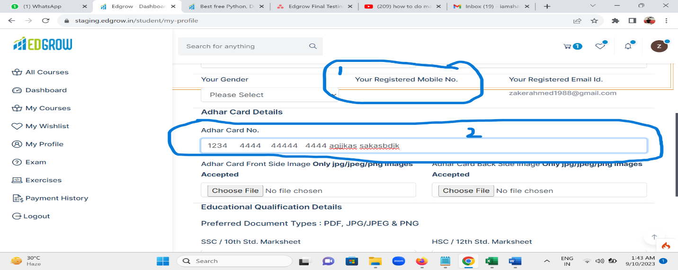

* [Exam](https://staging.edgrow.in/student/exam) 🡨 it will be perfectly worked we no need to change here its fine

# [Exercises](https://staging.edgrow.in/student/exercises) 🡨 when i clicked here it navigate to different page that show me

# **ErrorException**

Undefined variable: exercises  [search →](https://www.duckduckgo.com/?q=ErrorException+Undefined+variable%3A+excercises)

Based on my assessment, the developers have fixed the bug in accordance with its priority.

* [Payment History](https://staging.edgrow.in/student/payment-history) 🡨 when I check payment history it will be properly displayed

| **Order Id** | **Courses Purchased** | **Date Of Purchase** | **Amount Of Purchase** | **Details** |
| --- | --- | --- | --- | --- |

As per my point view so here in payment history everything looks fine

* [Logout](https://staging.edgrow.in/student/logout) 🡨 when I click logout button I successfully logout from the application it will be perfectly worked we no need to change here its fine.

I am login again I do same thing for log In with gmail option and press continue with my gmail account the account will successfully open and redirect to login page sucessfully.

After successfully login Im able to search the courses,while I search python course so im getting the entire detail of that perticular course which includes course details show as complete detail which I mentioned on the attached image.

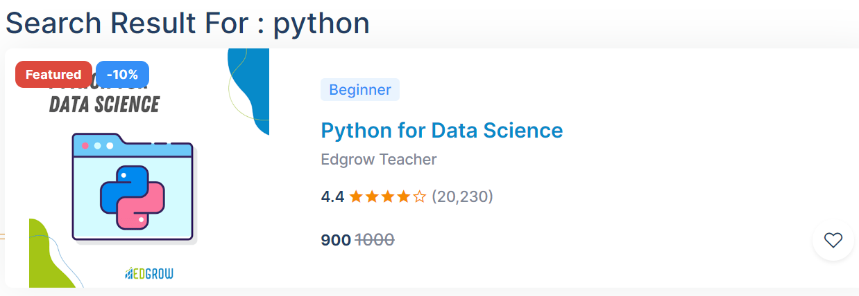

When I Click that course, it will successfully went my add to card and im trying to the do payment for buying the course I do that payment steps for purchasing the course.

##### Verify the payment procedure at time of product purchase

Sub Total

₹ 900.00

GST (18 %)

₹ 162.00

TOTAL PRICE

₹ 1062.00



Top of Form

Bottom of Form



But while checkout the payment I select UPI payment methods user paid Rs-900 + GST 162 = Total 1062 but while I scan the QR code payment show us Rs-1253.16 that show me extra amount which is Rs-191.16.

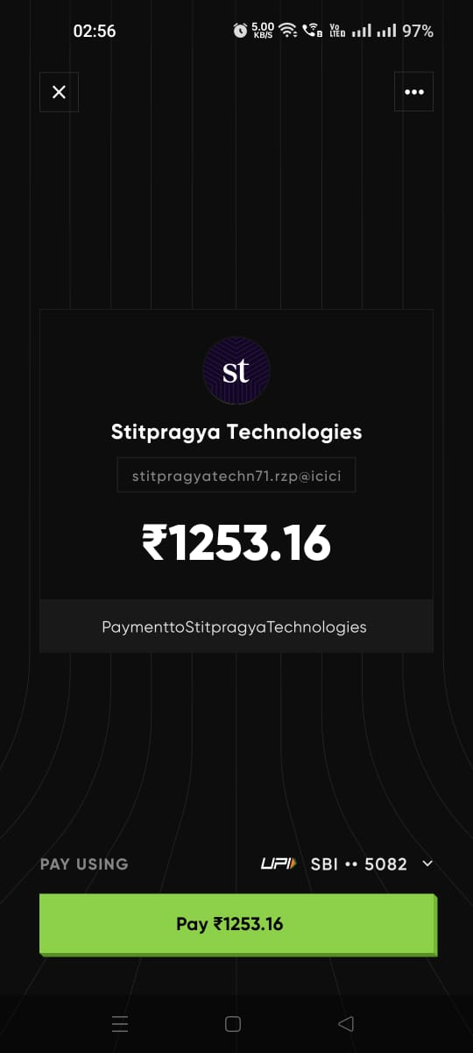

Please refer to the attached image for a clearer understanding of the defect

According to my observation in payment section here some calculation error here will be observed that is Bug and I specified it HIGH Severity & Priority developers fixes these bugs immediately until unless as a tester I cannot process further.

Same thing is happening while I’m checking to purchase some different product (Course)same calculations errors will be there as testers I specified this as critical bug the Developers fixed this immediately.

After that I will verify some other payment method like NET BANKING when click net banking dropdown button I want the do payment with STATE BANK OF INDIA but in dropdown button I will see multiple banks list in dropdown but state bank of India is missing in the dropdown that’s why I cannot make the payment because I am using SBI Net Banking and I don’t have any other bank account.

So as a User’s point of view how they purchase the product or Course.

Same thing will be happening with our users why because mostly peoples used SBI bank so if they faced these issues so definitely, they frustrate with our website and might be they will not come at Edgrow because of these issues so here I’m consider this is a critical Bug Developers fixed it immediately.

After Net Banking I’m verifying the Credit Card Option So Here Credit card Text field accept only 16 numbers which is required and credit card text field does not allow

**Add New Card** 🡨 it is aligned properly and also perfectly worked.

**Card Number** 🡨 it perfectly worked according to requirement (textbox does not accept alphabets)

**Expiry**  🡨 it is aligned properly and also perfectly worked.

**Card Holder's name** 🡨 it is aligned properly and also perfectly worked.

 🡨 CVV Textbox it is aligned properly and also work fine.

**CVV**

Save card securely for future payments 🡨 these options are also perfectly work fine.

Know More

But after credit card mandatory fields are worked according to requirement but here I do negative testing I pass valid credit numbers and invalid card holder Name and invalid CVV and press the continue button so I got OTP of my Mobile as per my view if I passed invalid input the OTP has not come to my mobile and either warning massage should be displayed and again here observed calculation is not properly match to expected and actual.

I've reported these bugs as critical, and I urge developers to address them immediately.

So these all are My Observation about Edgrow i checking here some basic functionality of application which working according to customer requirement or not and also customer expectation or not I see multiple defect in which I HIGHLIGHTS on YELLOW And REDLINES kindly check that entire reports which prepared I am awaiting your feedbacks which important for me for future endeavors.

**NOTE:** Please review the entire report where I've highlighted the defects in yellow and red lines.

Regards

Shaikh Zaker

Software Test Engineer

Codem Power Solution Pvt Ltd.